**<https://learn.microsoft.com/en-us/power-apps/>**

**Vishal Sharma (US)-Trainer**

AI: 5 categories in AI -language speech vision search & season.

Example: When any huge amount transaction happens all of a sudden from my account, bank person calls us and gets confirmation. A Normal detection happens which is due to vision category. If we need to build our own models, to train the data, we can use ML. We need a programming expert in that case like python or C#.

NOTES:

1. admin.powerplatform.microsoft.com
2. make.powerapp.com
3. app.powerbi.com
4. <https://learn.microsoft.com/en-us/power-platform/developer/get-started>
5. Learn.microsoft.com
6. <https://learn.microsoft.com/en-us/power-platform/power-fx/formula-reference>
7. <https://customers.microsoft.com/en-us/home?sq=&ff=&p=0>
8. <https://learn.microsoft.com/en-us/training/paths/power-plat-fundamentals/>

Dataverse **allows data to be integrated from multiple sources into a single store**, which can then be used in Power Apps, Power Automate, Power BI, and Power Virtual Agents.

**Dataverse (formerly known as CDS) is a cloud-based storage space** that organizations can use to store business application data securely. It is more than just a data storage platform since it provides some great features for data integration, security, and data management.

The files behind the scenes are stored in Azure Blob Storage. You won't have access to the storage account directly and must download the files using the Dataverse Web API.

Dataverse lets you securely store and manage data that's used by business applications. Data within Dataverse is stored within a set of tables. A table is a set of rows (formerly referred to as records) and columns (formerly referred to as fields/attributes). Each column in the table is designed to store a certain type of data, for example, name, age, salary, and so on. Dataverse includes a base set of standard tables that cover typical scenarios, but you can also create custom tables specific to your organization and populate them with data by using Power Query. App makers can then use Power Apps to build rich applications that use this data.

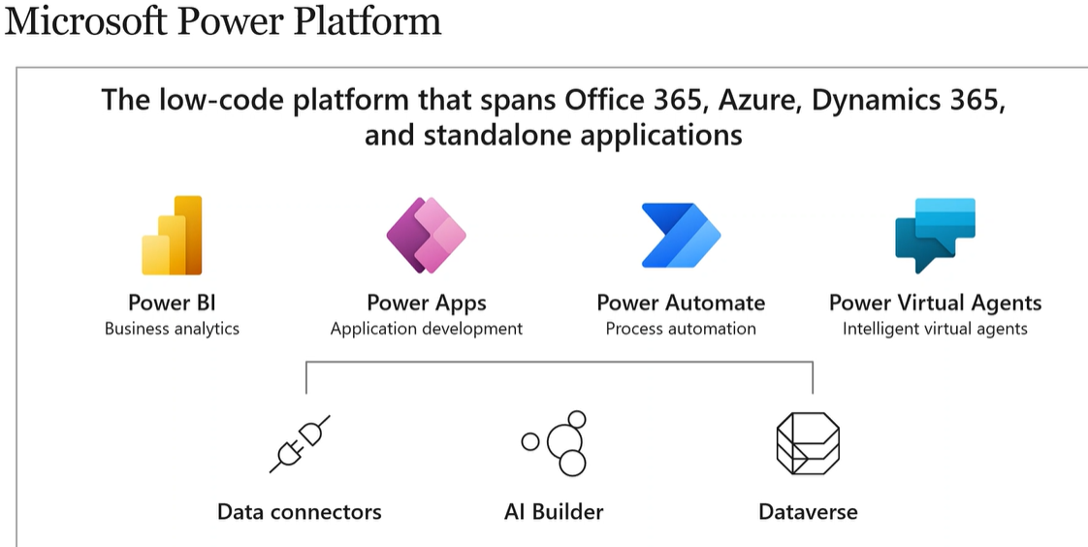

Definition:

It is a cloud technology that offers no code or low code platform to build the apps or solution.

Components:

1. Power BI-powerful tool to create reports, we can bring data from diff data sources and combine together & load into BI & see the reports or dashboards. Both live & static data can be used.
2. Power apps: No code low code environment that helps build custom apps for business use.
3. Canvas-UI is in our hand, can be used on mobile, tab and browser, can bring used data from many data sources like excel, SharePoint etc. Internal use only. We can design canvas app using different controls like gallery, input, media, chat , components, AI controls. We can bind the controls together using excel like formulas. Ways to create: Blank, data (easiest way-2), template (easiest way-1).
4. Modern driven apps-data source internal to power platform that is dataverse is the only data source used here, within organization. Internal use only
5. Power pages-can use only dataverse as data source, external users can use by registering & logging. This is an external app. Internal & external use.
6. Power Automate-can automate tasks/process, cannot access desktop applications using cloud flows
7. Power virtual agents (chatbots)-we need to know Azure (cloud technology) to build chatbot, chatbot can answer and ask questions to users, it should be transparent & keep the privacy & safe to use, in banking applications (credit card details will be asked which should be secure)

Features:

1. AI Builder
2. Microsoft dataverse-One & Only internal data source within power platform. CDS (common data service) was its earlier name which was working with CDM (Common data model)
3. Tables: standard, activity, virtual
4. Column(data types)
5. Relationship: One to many, many to one, many to many
6. Business rules(Logic/validation)
7. Views (to see data)
8. Forms
9. Charts
10. Dashboards
11. Keys
12. commands
13. Data connectors-over 800+ connectors are there, helps data to be brought by diff data sources. Developer experience is required for creating custom connectors.

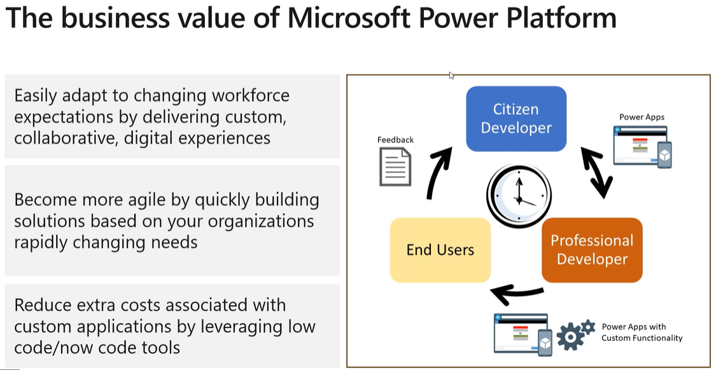

1. People with 0 code knowledge can use this to build apps or solutions
2. People can reduce the manual/repetitive works and automate the rule-based process using power automate
3. BI: Data analysis reports and dashboards gives us an insight with the complete information on any process by looking at the dashboard/reports
4. One stop solution where business can connect dataverse (brings data from diff data sources) and build power apps and also automate the processes using the data from dataverse using power automate & create dashboards and reports using these data for data visualization.

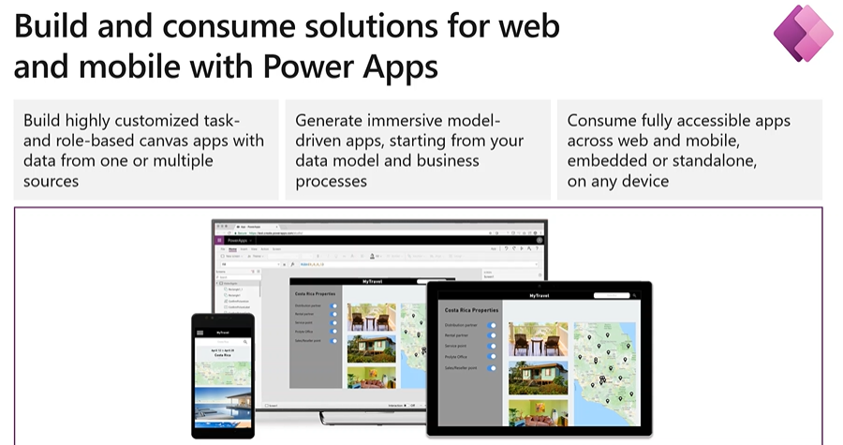

Canvas, modern driven and power pages are the types.

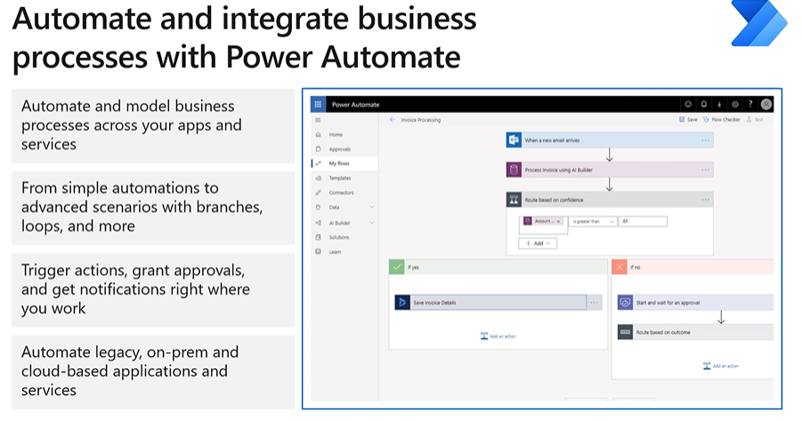

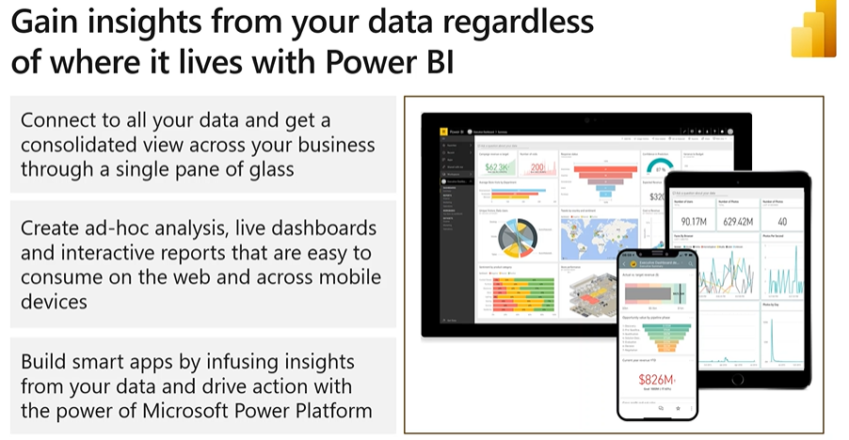

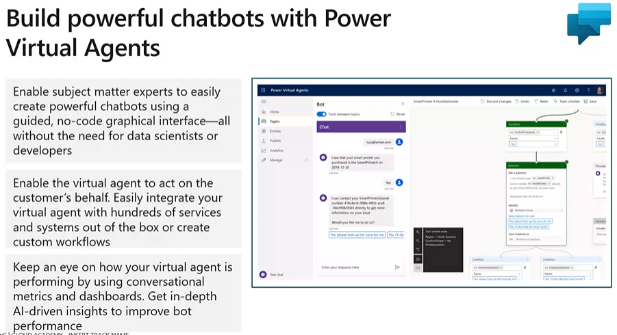

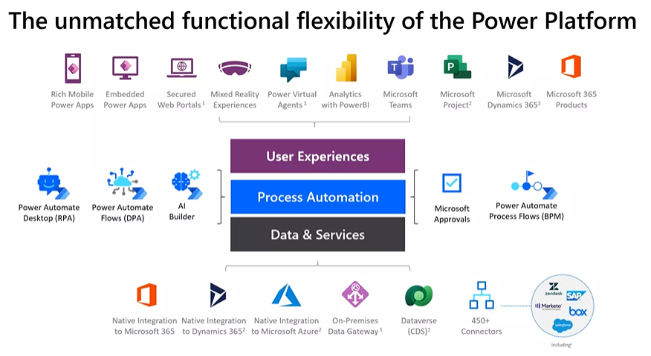

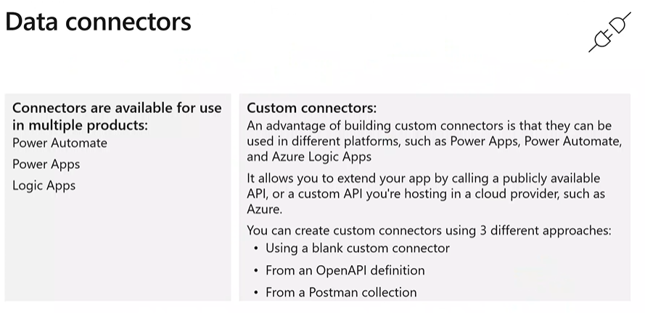

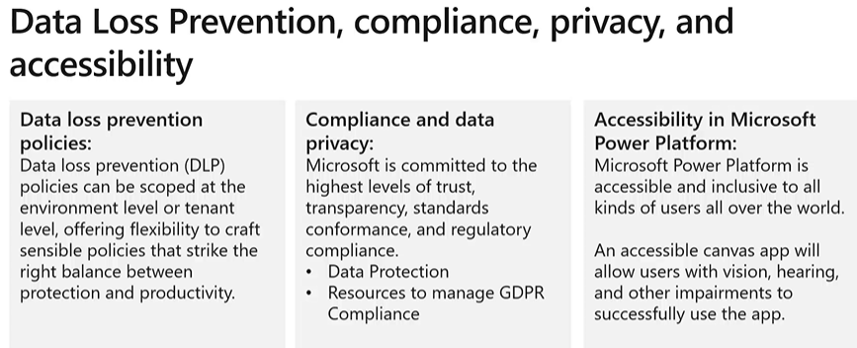

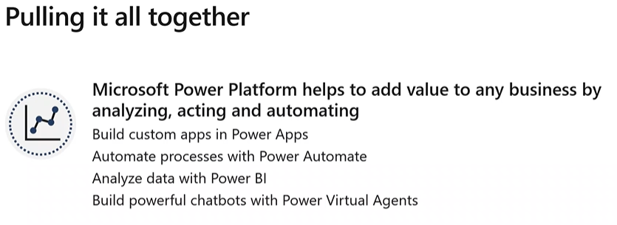

To deliver training, we need IT equipment like hard drive which has info, we need system like laptop/desktop. We need 1 headphone with noise cancellation functionality. This organization supplies all this & maintains. Manually many issues will occur while doing this end to end process.

***Solution:*** *Canvas app created using Power apps will have list of equipments. Form will open to create a ticket with the information like return date & other things. Moment this form is submitted, ticket is assigned to the user with few regulations & this msg/mail can be sent to the user using the flow created in power automate. Power BI-data is gathered when form is filled and data is used for dashboard creation or report generation (equipment available/used, instock or new equipments). Chatbot-IT support is required when this equipment is not working & IT closes its work by 5pm and later the chatbot can help with the solution to the users until IT shadows them the next day.*

URL: admin.powerplatform.microsoft.com

License:

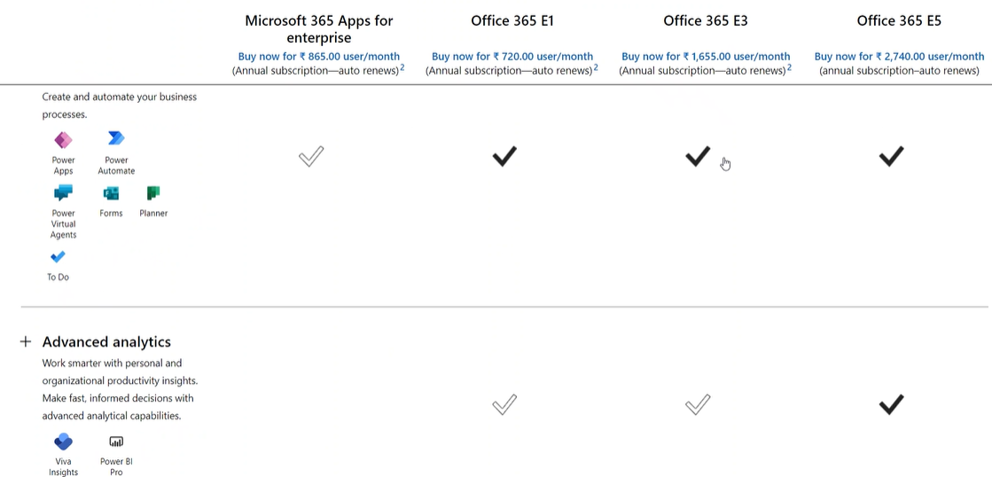

While creating environment, if we enable this option “create database for environment” then dataverse will get created else we will not be able to use dataverse.

Why create multiple environment? If development is going on, I don’t want to use the same for testing purse hence we can make use of 3 environments to achieve similar tasks In the respective environment.

Once environment is ready, make.powerapps.com we need to select the environment from below. That app gets created in the chosen environment

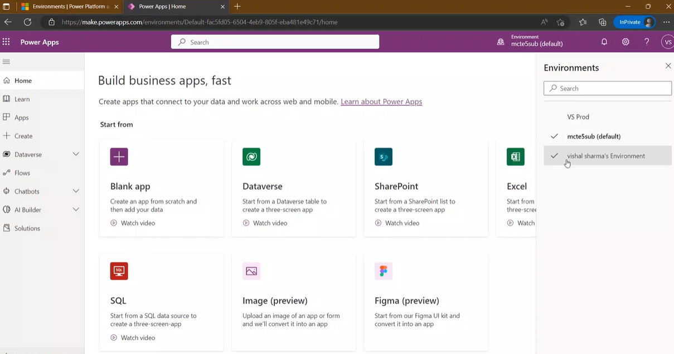

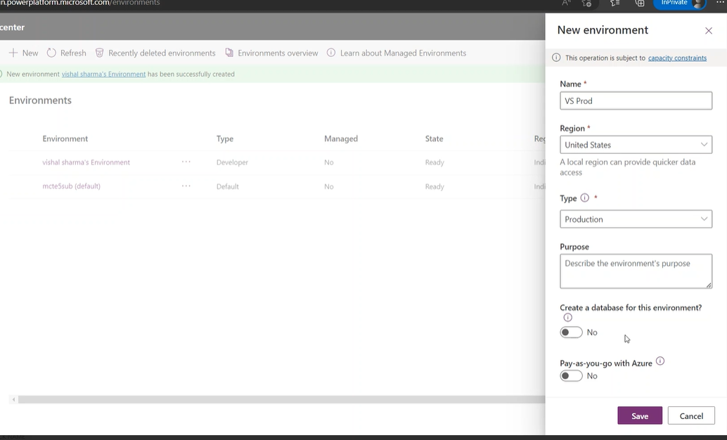

We can integrate Power platform with Azure, office 365, dynamic 365.

When we require to transfer things from 1 environment to another (dev->testing or prod), we need to package/bundle everything that needs to be transferred. We will create a container/SOLUTION in environment 1 which is nothing but a solution (can be managed or unmanaged). While transporting we need to export from dev->prod and import from prod->dev, during this if solution is unmanaged, after transferring the things, prod ppl can make changes to these data that was transferred from dev which is not a good idea. We need to pass data by exporting as managed where prod users cannot make any changes to the data transferred from dev.

NOTE:

1. Modern driven app can use only Dataverse & no other connectors, what if I want to use data outside dataverse like SQL?

Ans: We need to create & store data in dataverse & then use (Which is not feasible incase of large amount of data)

Virtual table is the only option to bring data from other source and use in dataverse. It is a custom table in Microsoft dataverse that has columns containing data from external data source

1. Dataverse is premium for power automate and not for canvas app
2. Developers require license but consumers don’t need license to consume data

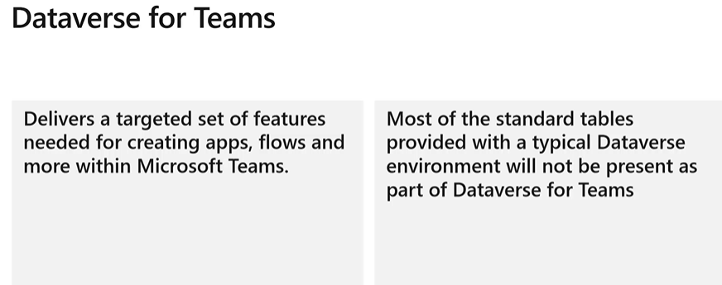

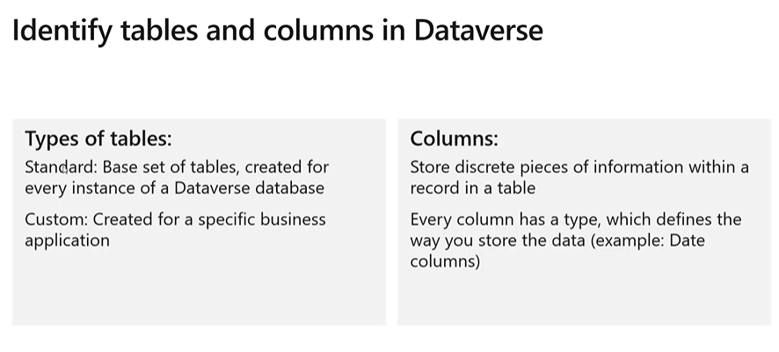

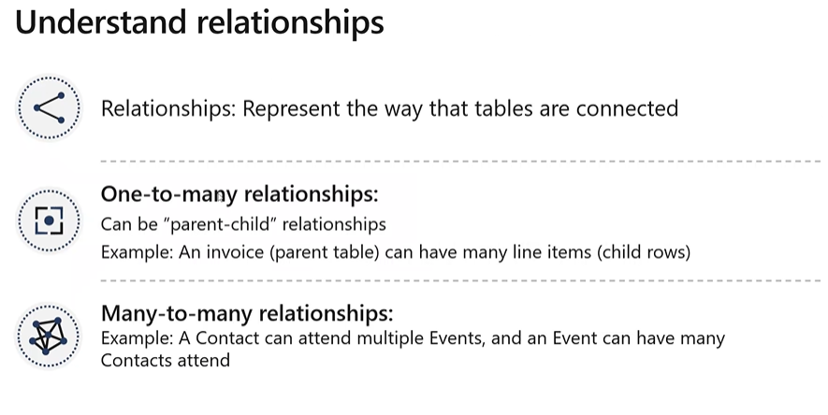

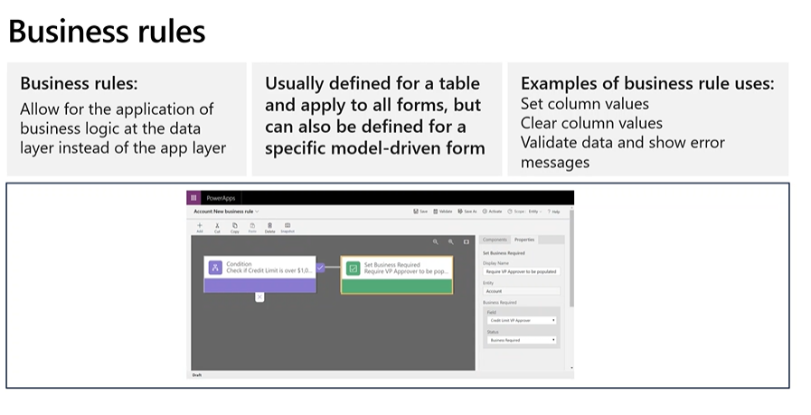

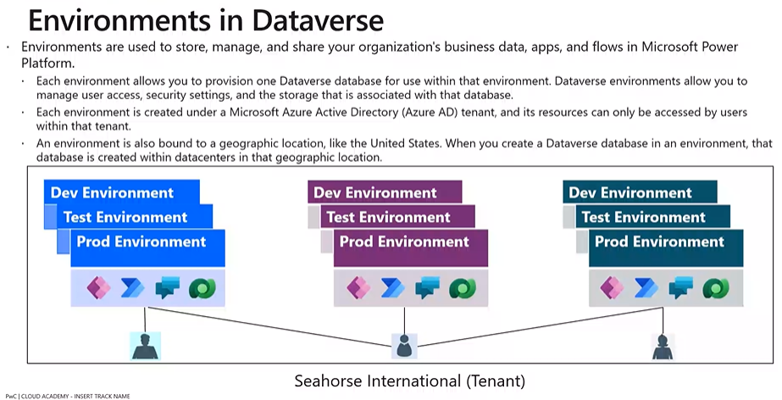

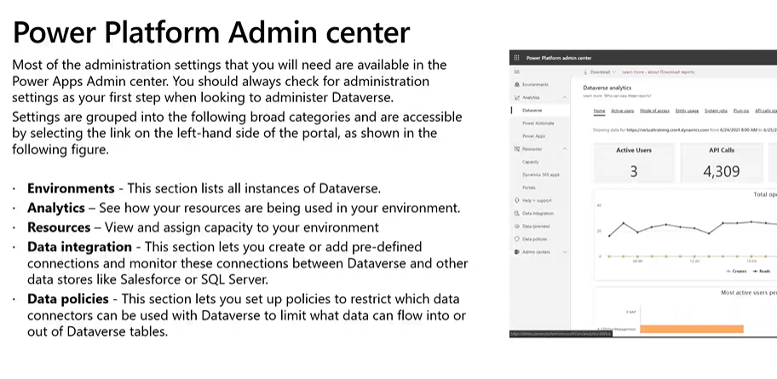

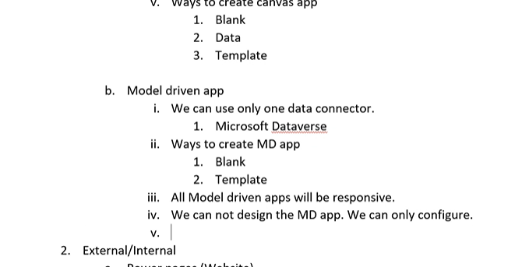

Power automate

It is a service to automate the task or process using flows. Flow is a series of steps created using connectors.

Types of flows.

1. Cloud flow (Event driven flow)
2. Automated.
3. Instant (Manually)
4. Schedule (Timer)
5. Desktop flow (UI flow) Robotic process automation
6. Attended
7. Unattended
8. Business process flow (Microsoft

Exercise: There are 2 folders Data & Final. If file is approved, the same should move to Final folder. If rejected, file should be deleted.

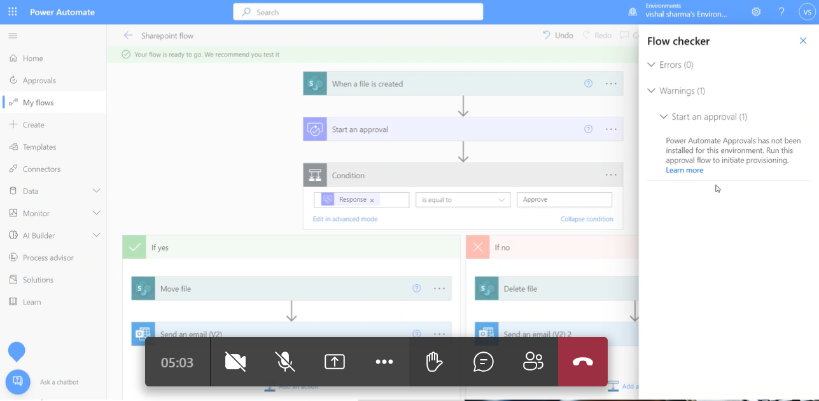

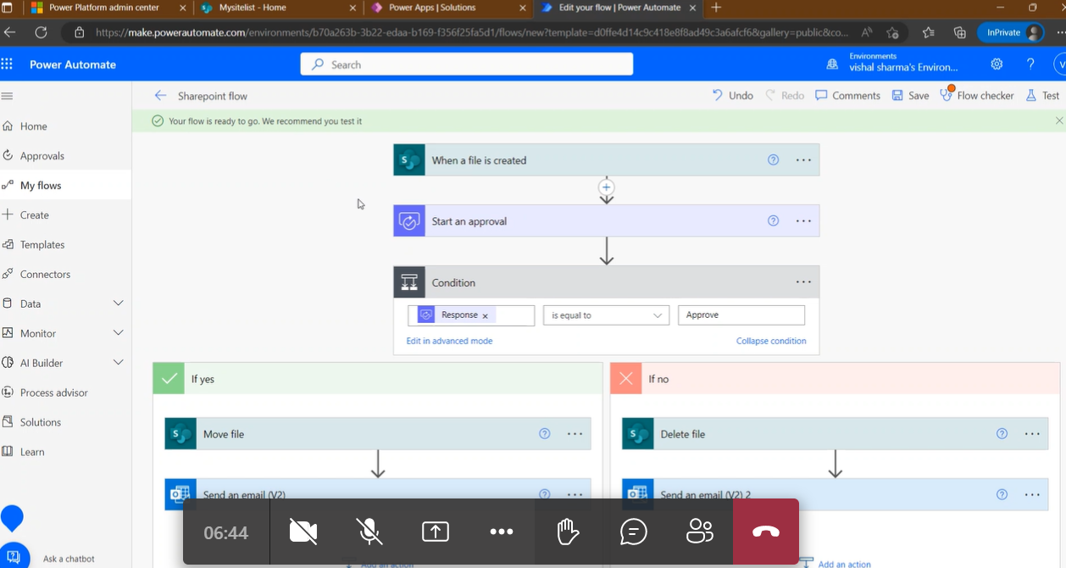

Power BI

Is a tool to analyze data coming from different sources

1. Power BI desktop – Best way to work with
2. Get data
3. Transform (Clean data) (Power Query Editor)
4. Load data
5. Report
6. Visualization
7. Publish
8. Power BI mobile
9. View the reports
10. Power BI services